CHAPTER 1
INTRODUCTION

1.1 Background
ResBack is a web-based feedback and analytics system intended for the College of Computing and Information Sciences (CCIS) of Mariano Marcos State University. The project responds to the need for an accessible channel through which students can express concerns and authorized personnel can identify recurring issues. Its purpose is to organize feedback, protect submitter identity in shared analytical views, and present information that can support departmental decisions.
The project proposal identifies two concerns: students may hesitate to report problems when their identities are exposed, and manually organized reports can be difficult to consolidate and monitor. These concerns motivate the development of a centralized feedback platform. Research in higher education also establishes the relevance of complaint handling. Msosa [1] examined service failures among students in South African public universities, while Azahari et al. [2] investigated communication, decision-making, and staffing problems in an institutional ICT complaint process. These studies provide context for the project without establishing the prevalence of the same conditions within CCIS.
Collecting comments alone does not explain which concerns occur repeatedly or how users feel about them. Sentiment classification assigns an evaluative label to text and is distinct from identifying its subject [3]. ResBack combines these two functions by classifying feedback as positive, neutral, or negative and organizing it under concern topics. The current application uses a configured Gemma model through the Google Gemini API, then validates and normalizes the returned results.
ResBack presents sentiment summaries, language categories, trends, and ranked concerns through a role-restricted dashboard. Students and faculty can review their own submissions, while authorized personnel can examine summaries and generate reports. Feedback remains linked to an account internally for personal history and submission safeguards. Accordingly, the system provides confidentiality and identity suppression in analytical views; it does not provide complete anonymity from the underlying database.

1.2 Statement of the Problem or Gap
The project addresses the need to turn privately submitted CCIS feedback into organized, interpretable information for faculty and administrators. The software problem is to connect access control, dependable submission processing, multilingual sentiment classification, and concern prioritization within one application. The following questions guide its development and evaluation.
1. How can authenticated students and faculty submit feedback and review their history while keeping account identity out of faculty-facing analytics and feedback exports?
2. How can the system screen prohibited content, limit repeated or excessive submissions, and preserve a clear processing status when analysis fails?
3. How can Gemma-assisted analysis classify sentiment, identify languages, and group related concerns in English, Tagalog, Ilocano, and mixed-language feedback?
4. How can sentiment, frequency, confidence, and recency be combined into understandable concern rankings and filtered reports?
5. How can the system be evaluated for functional correctness, access control, classification quality, usability, and consistency of analytical outputs?

1.3 Objectives

1.3.1 Main Objective
To develop and evaluate ResBack as a web-based CCIS feedback system that provides confidential submission, Gemma-assisted sentiment and language classification, and algorithmic concern ranking to support the review of campus concerns.

1.3.2 Specific Objectives
1. To define the functional requirements, privacy boundaries, and permissions of Student, Faculty, Admin, and Super Admin accounts.
2. To implement account access, personal profiles, feedback submission, private feedback history, and safeguards against duplicate, excessive, and prohibited submissions.
3. To integrate Gemma through the Gemini API and validate sentiment, confidence, keyword, language, and concern-topic outputs.
4. To organize related feedback and compute concern scores using negative volume, negative ratio, model confidence, and recency.
5. To provide filtered dashboards, Excel exports, and PDF reports that omit submitter account identity fields.
6. To evaluate application behavior and analytical quality through automated tests, controlled examples, human-labeled feedback, and user task evaluation, then refine the system through Agile Data Science 2.0 iterations.

1.4 Scope of the Project
The project covers the design, development, and evaluation of a browser-based feedback and analytics application for CCIS. Its intended users are students, faculty, administrators, and super administrators. Public registration creates Student accounts. Students and faculty may submit feedback and access their own history. Faculty, Admin, and Super Admin accounts may view dashboards and download reports. Admin accounts may manage eligible Student and Faculty accounts and delete feedback. Super Admin accounts may additionally manage other administrators and delete other accounts. Self-directed role changes, deactivation, and account deletion are restricted.
Feedback is limited to the active CCIS category and text submissions of 10 to 2,000 characters. The system checks normalized duplicates within the same account and category over 24 hours and limits stored submissions to five within the configured ten-minute rate-limit window. Configured rejection terms are checked before external analysis. Rejected submissions are stored with a rejected status and excluded from analytical reports. Accepted submissions proceed through pending, analyzed, or failed processing states.
Analytical functions include three sentiment classes, confidence values, keywords, normalized concern topics, and language categories. Supported categories distinguish English, Tagalog, Ilocano, their two-language combinations, a three-language combination, and other languages. Authorized users can filter records by date and language, inspect ranked concerns and examples, and download matching XLSX and PDF outputs. The application also provides nickname and profile-photo settings.
The project uses an existing Gemma model through an external API. It does not train a new language model or implement the proposal's earlier TF-IDF and Logistic Regression pipeline. Internet access and an available API service are required for automated analysis. Dictionary screening cannot identify every abusive expression and may reject legitimate text that quotes a prohibited term. Language and sentiment labels remain model estimates, particularly for sarcasm, ambiguous wording, and mixed-language statements.
The current scope excludes university-wide deployment, a dedicated mobile application, assignment of complaints to offices, response messaging, and issue-resolution or closure tracking. Processing status describes what happened to the submission and its analysis, not whether an institutional problem has been resolved. Rankings support human review and do not verify allegations, determine disciplinary action, or guarantee the urgency of a concern. Account fields are withheld from analytical views, but identifying details voluntarily written inside feedback are not automatically redacted.

1.5 Significance
For students, ResBack provides a consistent place to submit feedback and revisit personal submissions without exposing account details in faculty-facing reports. For faculty, the system offers both a submission channel and summaries that can help identify recurring experiences within CCIS. These benefits depend on clear communication of the application's confidentiality boundaries and responsible use of the information.
For administrators and CCIS decision-makers, the dashboard and reports can reduce the effort needed to consolidate comments and locate repeated concerns. Ranked topics and supporting examples provide a starting point for review, while permission controls distinguish analytical access from account-management authority. For the project team and future researchers, ResBack provides an application in which software behavior, language-model output, and prioritization rules can be examined separately and improved through recorded iterations.

CHAPTER 2
REVIEW OF RELATED LITERATURE

2.1 Review of Related Literature and Systems
The review connects complaint-management research with the analytical functions required by ResBack. It considers access to reporting, the organization of complaint records, interpretation of written feedback, and support for institutional decisions. The related systems provide design benchmarks, while their different settings and evaluation methods limit direct transfer of their findings to CCIS.

2.1.1 Complaint Handling in Higher Education
Msosa [1] used a quantitative, descriptive, cross-sectional design involving 430 full-time students across three South African public universities. The study examined service failures and perceptions of complaint management, identifying funding and academic registration among the reported service-failure areas. Its relevance to ResBack is the treatment of student complaints as information for evaluating institutional services. The results concern the participating universities and do not establish that the same complaint patterns or satisfaction levels exist in CCIS.
Azahari et al. [2] studied an ICT complaint process in a Brunei higher education institution. The investigation identified difficulties involving decision-making, communication, and staffing, and recommended more systematic procedures and clearer responsibilities. This supports ResBack's emphasis on organized records and understandable summaries. It also shows why software alone cannot guarantee a response: personnel and procedures remain necessary. ResBack therefore supports the identification of concerns while leaving institutional investigation and resolution to authorized people.

2.1.2 Sentiment and Topic Classification
Pang, Lee, and Vaithyanathan [3] examined positive and negative movie-review classification using Naive Bayes, maximum entropy, and support vector machines. Their machine-learning approaches exceeded the human-produced baselines used in that experiment, but the work also demonstrated that sentiment classification presents challenges beyond conventional topic categorization. A topic identifies what a comment concerns; sentiment identifies its evaluative direction. These are separate analytical dimensions in ResBack. The study supports this distinction rather than providing performance evidence for Gemma or for Philippine campus feedback.
ResBack applies sentiment and topic analysis together because a favorable and an unfavorable comment can refer to the same service. Language classification adds context for reviewing English, Tagalog, Ilocano, and mixed-language submissions. The application groups recognized language combinations and normalizes synonymous concern labels. These processing choices make aggregation possible, but their usefulness must be tested against locally relevant examples and human judgments.

2.1.3 Web Based Campus Complaint Management System
Alifat et al. [4] developed the Web-based Campus Complaint Management System using Waterfall, PHP, JavaScript, HTML, CSS, and MySQL. The study describes a centralized web application for student and staff complaints and reports alpha and beta evaluation involving developers and users. For ResBack, the useful design precedent is the connection between an accessible reporting interface, stored complaint records, and administrative review. Its reported evaluation concerns that particular application and cannot be treated as ResBack's usability or reliability result.
ResBack adopts browser-based access and role-restricted administration, then adds sentiment, language, and concern analysis to its feedback workflow. Its development approach remains Agile Data Science 2.0. The methodology used by a related system serves as a point of comparison rather than determining the methodology of this project.

2.1.4 Complaint Management at West Visayas State University
Muzones and Pomperada [5] describe a web-based Complaint Management System for West Visayas State University Himamaylan City Campus. Their research digest presents routing, progress tracking, notifications, analytics, and role-based access, and identifies AI integration among future directions. The study provides a Philippine institutional benchmark for combining complaint records with administrative visibility. Its short research-digest format provides less methodological detail than a full evaluation report, so its performance and financial claims should not be transferred to another project.
ResBack uses dashboards and controlled access to support review, but its current functions concentrate on feedback analysis. Routing, notifications, and resolution tracking described in the related system are outside ResBack's present scope. This distinction prevents an analytical dashboard from being presented as a complete complaint-resolution service.

2.1.5 Online Student Complaints at Bowen University
Emuoyibofarhe et al. [6] investigated student complaint handling at Bowen University and developed an online model using PHP, AJAX, JavaScript, HTML, CSS, and MySQL. The study used a student survey to examine the existing process and preferences for electronic complaint handling. It supports the value of collecting stakeholder input before defining a reporting interface. Its findings describe that institutional setting; they are not evidence that CCIS users have already accepted ResBack.
For ResBack, the corresponding design choices are centralized storage, accessible forms, and efficient retrieval of feedback. Stakeholder review remains part of the evaluation plan so that the clarity of instructions, status messages, and report interpretation can be examined with the intended users.

2.1.6 Decision Support for Educational Facilities
Albader [7] developed a decision-support approach for educational facilities management using condition prediction and agent-based models of classroom interactions and maintenance-budget allocation. The dissertation demonstrates how structured information and explicit models can support decisions involving institutional resources. Its setting is educational-facility management, and its modeling approach differs from ResBack's text analysis and weighted concern scoring. It is relevant as a decision-support concept, not as validation of ResBack's algorithm.
ResBack similarly presents information for a human decision-maker. Its ranked concerns combine several visible factors instead of counting mentions alone. The interpretation of a high score must still consider the supporting comments, the amount of evidence, and the context of the reported issue.

2.1.7 Synthesis and Project Contribution
The reviewed work supports three requirements: a usable reporting channel, organized information for institutional review, and a defined connection between data and decisions. Complaint systems [4]-[6] supply workflow precedents, complaint-management studies [1], [2] explain organizational concerns, and decision-support research [7] motivates structured prioritization. ResBack combines these ideas with sentiment classification [3] in a CCIS-focused application.
The project's contribution is this specific integration of confidential submission, multilingual analytical labels, topic normalization, concern scoring, and filtered reporting. This is a practical design contribution for the intended setting, not a claim that each component is new. The research gap to be evaluated is whether the integrated application produces dependable, understandable outputs for CCIS users while maintaining the intended access and privacy boundaries.

2.2 Conceptual Framework
The conceptual framework links feedback inputs, controlled processing, and decision-support outputs. Inputs consist of authenticated submissions, their CCIS category and time, and the application's screening rules. Account information is used for access and submission control, while the analytical pipeline operates on the comment and its derived attributes. Figure 1 summarizes these relationships.
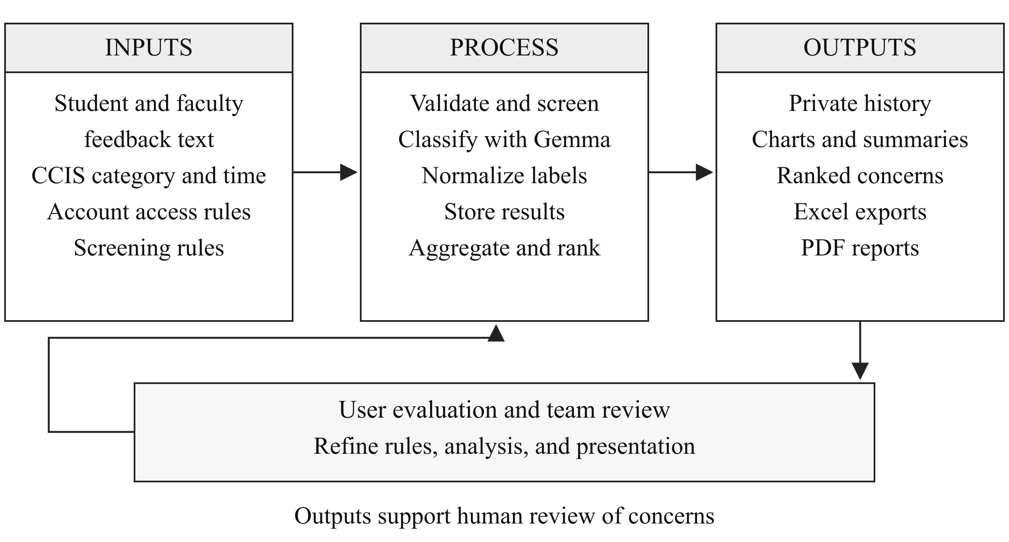
Figure 1. Conceptual framework of ResBack
Processing begins with validation, duplicate checks, rate limiting, and dictionary screening. Accepted text proceeds to Gemma-assisted classification. The application validates the result, normalizes language and topic labels, stores the analysis, and aggregates eligible records. Rejected text is retained with a processing status but bypasses external analysis and reporting. A failed analysis remains distinguishable from a successful classification.
Outputs include private submission history, sentiment and language summaries, ranked concerns, and downloadable reports. These outputs help authorized users identify matters for further review. Evaluation findings feed back into the software-development process through revisions to validation, prompts, normalization rules, ranking logic, or presentation. This loop represents improvement of ResBack; it does not represent an implemented complaint-resolution workflow or automatic retraining of Gemma.

CHAPTER 3
METHODOLOGY

3.1 Project or Research Design
ResBack follows a developmental research design supported by software testing and descriptive evaluation. The principal artifact is a functioning feedback and analytics application. The work connects the identified reporting needs with implemented features, then evaluates whether those features behave as specified and produce useful analytical information. Quantitative evaluation will summarize task outcomes, classification results, and response times; qualitative review will examine misunderstandings, errors, and suggested improvements.
Agile Data Science 2.0 provides the development methodology. Jurney [8] describes iterative construction of analytics applications through progressively useful data products. Its data-value pyramid connects records, charts and tables, reports, predictions, and actions. ResBack applies these levels to campus feedback rather than copying the book's example technology stack. The application uses Laravel and a relational database, with Gemma supplying the language-model inference. The levels organize development and review; they are not a claim that users completed a fixed sequence of experimental trials.
The existing application provides the technical basis for the methodology. Formal user evaluation and labeled-data evaluation will follow the procedures below. These evaluations will establish the evidence needed to judge the system; the presence of implemented features or automated test files alone does not establish classification accuracy, user acceptance, or institutional impact.

3.2 Method or Approach

3.2.1 Setting and Stakeholders
The intended setting is CCIS at Mariano Marcos State University. Students and faculty provide feedback and evaluate submission and history tasks. Faculty and authorized administrators review dashboard interpretation and report usefulness. Administrators and super administrators evaluate the account-management actions allowed by their roles. The project team is responsible for implementation, documentation, and testing. Participation in formal evaluation will be voluntary and arranged through the appropriate institutional process.
A purposive selection of participants will cover the user roles rather than claim statistical representation of the entire college. The evaluation record will state the actual number of participants, their roles, recruitment conditions, and completed tasks. Role-limited functions will be tested using controlled accounts so that participants do not need access to other users' real submissions.

3.2.2 Requirements and Data Collection
Requirements are organized from the ResBack proposal, the current application behavior, and the use case, activity, and class models. Each requirement will be linked to an actor, an expected result, and a verification method. Stakeholder walkthroughs will examine the clarity of submission instructions, privacy expectations, useful report filters, and the meaning of concern rankings. Notes from these sessions will be converted into specific revisions and acceptance conditions.
Two kinds of test data will be maintained separately. Controlled examples will exercise functional boundaries, permission checks, prohibited terms, duplicate submissions, and API failures. An authorized, de-identified set of feedback will support analytical evaluation. The latter will include the three sentiment classes and the intended single-language and mixed-language categories. Artificial examples will be labeled as test cases and will not be counted as evidence of actual campus concerns.

3.2.3 Application of Agile Data Science 2.0
Figure 2 maps the five levels of the data-value pyramid to ResBack. Each level produces an inspectable application output. Development may revisit a lower level when evaluation reveals a data-quality or interpretation problem. The project will record the requirement or hypothesis being examined, the relevant change, the observed result, and the decision to retain or revise it [8].
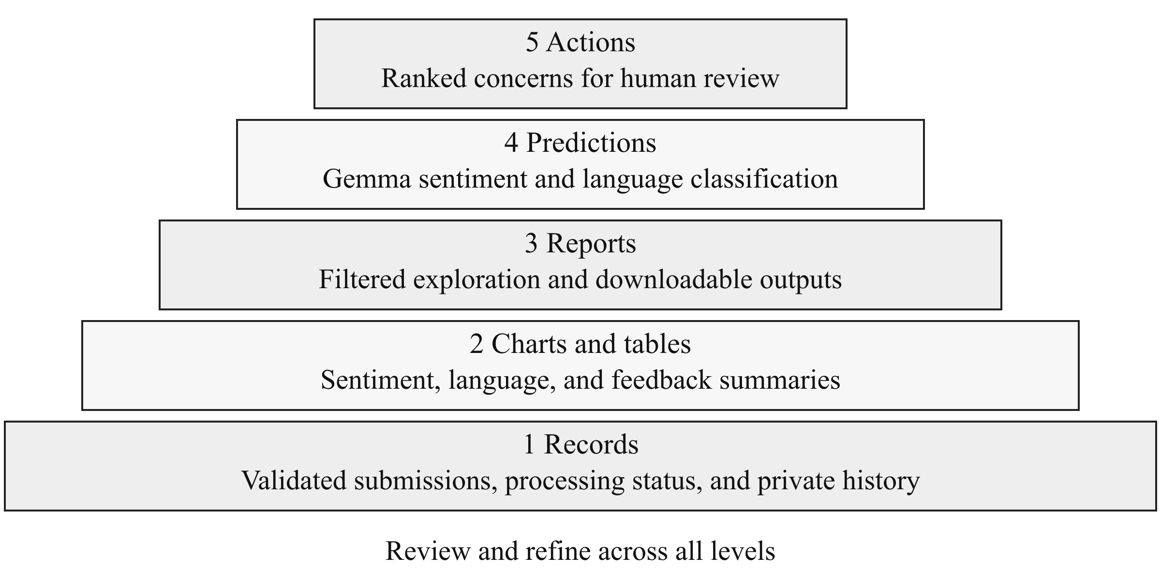
Figure 2. ResBack application of the data-value pyramid, adapted from Jurney [8]

Level 1 Records
The first level connects authenticated feedback entry to reliable storage and personal retrieval. Activities include defining account permissions, validating input, retaining submission time and status, and enforcing duplication and rate controls. The application artifacts are the registration and login functions, feedback form, database structures, and private history view. Verification checks that the correct owner can retrieve the record and that rejected or failed processing remains visible without being mistaken for successful analysis.

Level 2 Charts and Tables
The second level organizes stored data into sentiment counts, language distributions, trend charts, and a paginated feedback table. Activities include checking denominators, date boundaries, category restrictions, and the treatment of records without valid analysis. Deliverables are dashboard components and controlled datasets with known totals. The team will compare displayed values with independently calculated counts before using a chart to interpret a pattern.

Level 3 Reports
The third level combines summaries and examples into filtered views and downloadable outputs. Activities include applying consistent date and language filters and checking that account identity fields are omitted. Deliverables are the Excel export and PDF analytics report. Review will confirm that the same filter selects the same eligible records across the dashboard and exports, while recognizing that a PDF summary and a row-based workbook present different levels of detail.

Level 4 Predictions
The predictions level is implemented as inference about existing feedback: sentiment, language, and concern-topic classification. It does not forecast future campus incidents. Activities include refining the classification prompt, validating structured responses, normalizing labels, and comparing outputs with human annotations. Deliverables are the Gemma integration, normalization services, and an evaluation record. Because classification feeds the dashboard, work at this level also requires revisiting earlier charts and reports when the analysis rules change.

Level 5 Actions
The actions level connects analytical results to the decisions of authorized reviewers. ResBack provides ranked concerns and supporting examples to help users decide what deserves further examination. Activities include reviewing the ranking factors, inspecting low-evidence topics, and assessing whether the displayed order is understandable. The deliverable is a decision-support view. Any investigation, response, or service intervention remains a human and institutional activity outside the current application workflow.

Iteration and Review
At the end of each development iteration, the team will review the working increment, relevant tests, and unresolved observations. Changes to prompts, dictionaries, topic mappings, and scoring rules will be recorded alongside the application revision and model configuration used for evaluation. A regression check will follow changes that affect shared outputs. This process keeps improvements traceable and allows the same evaluation cases to reveal whether a revision fixes one problem while introducing another.

3.2.4 Tools and Development Environment
The application uses PHP 8.3 or newer and Laravel 13 for server-side processing, Blade with CSS and JavaScript for views, and Vite for frontend assets. MySQL or MariaDB provides relational storage in the intended deployment environment, while SQLite is available for development and automated tests. Chart.js presents dashboard charts, PhpSpreadsheet generates XLSX files, and Dompdf generates PDF reports. Git records application changes, and PHPUnit supports repeatable automated checks.
Gemma is a family of open models documented by Google [9]. ResBack invokes its configured Gemma model through the Gemini API and processes the returned text as structured analytical data. The research evaluates the integrated application's behavior rather than claiming to have trained Gemma. Each analytical evaluation will identify the model, prompt, generation settings, and application revision so that later differences can be interpreted.

3.2.5 Feedback Processing and Analytical Procedure
The submission pipeline first validates the active CCIS category and feedback length, checks duplication and submission frequency, and applies the configured rejection dictionary. A rejected record is saved without sending its content to the external model. Accepted feedback is saved as pending, then analyzed synchronously. Successful analysis stores sentiment, confidence, keywords, normalized concern topics, detected languages, and language confidence, and marks the record analyzed. Handled configuration, connection, response, or parsing failures mark the saved record failed.
The external request contains feedback text and classification instructions without separate account-identity fields. The prompt instructs the model to classify the feedback rather than follow instructions embedded in it. The response parser checks the sentiment class, numerical confidence fields, keywords, and language information before storing results. Topic normalization groups recognized synonyms, and language normalization maps combinations into the application's supported categories. These controls constrain the output format; they do not establish that every classification is correct.
Concern ranking operates on analyzed topics. Each topic receives a score out of 100 composed of 40 percent normalized negative-feedback volume, 25 percent negative ratio, 20 percent average confidence among negative classifications, and 15 percent average recency of negative feedback. Volume uses logarithmic scaling relative to the largest negative count in the selected scope. Recency decreases exponentially with a 30-day half-life. Topics with fewer than three associated records are marked as having limited evidence.
The scoring weights are implementation choices to be evaluated, not empirically established measures of urgency. Model confidence is also not assumed to be a calibrated probability. A feedback record can concern more than one topic, so topic counts need not sum to the number of distinct submissions. Evaluation will check the calculation on controlled records and examine how changes in volume, age, or confidence affect the displayed order.

3.2.6 Evaluation Procedure
Functional evaluation will trace the documented use cases to tests of normal, alternate, and exception flows. Checks will cover registration, login, logout, profile changes, feedback submission and history, analytics, filters, exports, deletion, and account administration. Permission tests will attempt both permitted and prohibited requests for all four roles. Privacy checks will confirm that personal history is restricted to its owner and that dashboard and export data omit account-identity fields. Test records will document expected output, observed output, and pass or fail status.
Analytical evaluation will use independently labeled feedback. Two reviewers familiar with the relevant languages will assign sentiment, language, and applicable concern labels using a shared guide, then reconcile disagreements. Ambiguous cases will remain identified for error analysis. The dataset will be separated into a development portion for prompt and rule refinement and a held-out portion for final assessment. The held-out examples will not be used to select prompts or normalization changes.
Sentiment results will be summarized through a confusion matrix, accuracy, and per-class precision, recall, and F1 scores. Macro F1 will give the three classes equal weight in the summary. Language-category accuracy and topic-label precision and recall will be examined separately, with results grouped by language where enough examples exist. The report will state the number of valid analyses and API or parsing failures; failed requests will not silently disappear from the reported evaluation population. Confidence values will be compared with observed correctness rather than reported as achieved accuracy.
Ranking evaluation will first compare application scores with independent calculations on controlled data. Faculty or administrative reviewers will then inspect representative ranked concerns and explain whether the factors and examples support their interpretation. Usability evaluation will ask participants to complete role-appropriate tasks, such as submitting feedback, locating a history entry, applying a filter, and downloading a report. Measures will include task completion, time, errors, assistance required, and ratings of clarity and ease of use. Comments will be grouped by recurring usability issue.
Performance evaluation will record response times for submission, dashboard access, and report generation under documented conditions. Submission time will include the external model request and will be distinguished from local application processing. Test conditions will identify the data volume, number of concurrent users, machine and network setup, and API configuration. Findings will guide subsequent iterations, with functional defects, misleading analytical outputs, and privacy failures receiving priority.

3.2.7 Data Handling and Ethical Considerations
Evaluation materials will use controlled or appropriately authorized feedback, remove unnecessary identifying details, and limit access to the project team and authorized reviewers. Participants will receive a clear explanation of the activity and may decline participation. Research copies will be kept separately from ordinary application records, with access and retention arrangements established before collection. Real feedback will not be copied into public demonstrations or repositories.
Users must be informed that the application links feedback to an account internally and that accepted text is processed by an external AI service. Removing identity fields from a report does not remove identifying information a person writes in the comment. Sentiment and ranking outputs will be treated as aids to review, with no claim that they verify a report or justify action against an individual. These boundaries will remain part of the user guidance and evaluation criteria.

REFERENCES
[1] S. K. Msosa, "Service failure and complaints management in higher education institutions," International Journal of Research in Business and Social Science, vol. 10, no. 3, pp. 514-521, 2021, doi: 10.20525/ijrbs.v10i3.1098.
[2] L. M. H. Azahari, M. L. A. Ason, N. D. Rossiman, W. T. Sion, and N. A. H. B. Idris, "ICT complaint management within a higher education institute in Brunei Darussalam: A case study," International Journal of Umranic Studies, vol. 3, no. 1, pp. 13-21, Jan. 2020, doi: 10.59202/ijus.v3i1.533.
[3] B. Pang, L. Lee, and S. Vaithyanathan, "Thumbs up? Sentiment classification using machine learning techniques," in Proceedings of the 2002 Conference on Empirical Methods in Natural Language Processing, 2002, pp. 79-86, doi: 10.3115/1118693.1118704.
[4] F. A. Alifat, O. A. Biodun, O. A. Oluwatobi, U. J. Ifeoma, and R. T. Amosa, "Web-based Campus Complaint Management System (WCCMS)," International Journal of Computer Trends and Technology, vol. 70, no. 10, pp. 28-36, Oct. 2022, doi: 10.14445/22312803/IJCTT-V70I10P105.
[5] E. Z. Muzones and J. R. Pomperada, "A complaint management system for enhanced efficiency at West Visayas State University Himamaylan City Campus," Philippine Social Science Journal, vol. 8, no. 2, p. 71, 2025, doi: 10.52006/main.v8i2.1343.
[6] O. N. Emuoyibofarhe, R. F. Famitimi, D. O. Olanloye, O. M. Awoniran, and G. M. Oti, "Development of a model for online students complaint management system. A case study of Bowen University Nigeria," LAUTECH Journal of Computing and Informatics, vol. 3, no. 1, pp. 64-73, 2023. [Online]. Available: https://laujci.lautech.edu.ng/index.php/laujci/article/view/70.
[7] H. B. Albader, "An overall policy decision-support system for educational facilities management: An agent-based approach," Ph.D. dissertation, Dept. Civil Engineering, Purdue University, 2018. [Online]. Available: https://docs.lib.purdue.edu/open_access_dissertations/1898/.
[8] R. Jurney, Agile Data Science 2.0: Building Full-Stack Data Analytics Applications with Spark, 2nd ed. O'Reilly Media, 2017. [Online]. Available: https://www.oreilly.com/library/view/agile-data-science/9781491960103/.
[9] Google, "Gemma models overview," Google AI for Developers. Accessed: Sep. 27, 2026. [Online]. Available: https://ai.google.dev/gemma/docs.

